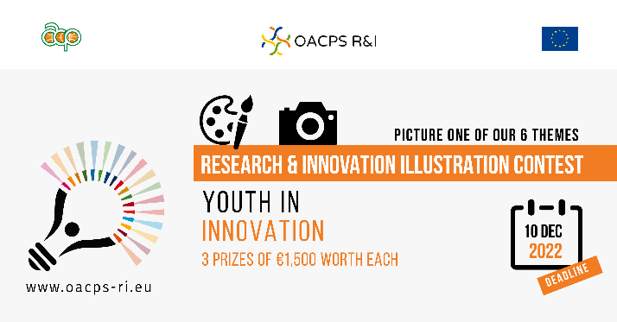
The illustration contest focuses on six thematic areas for their specific relevance to the OACPS R&I Programme.

One of them is about “Youth in innovation”.

Many OACPS member countries are characterised by a young population (and a youth bulge in Africa). This is a great development asset, if appropriately leveraged. Youth bring unique perspectives, and an entrepreneurial and innovative spirit.
Young innovators – in start-ups, fab labs, living labs, etc. - are already demonstrating their ability to create businesses and jobs, boost growth and find home-grown solutions to challenges to which they are or will be the most impacted, such as climate change, water scarcity, degradation of ecosystems, food and health security, etc.
The OACPS R&I Programme contributes to unleashing young people's creativity and innovation, by promoting digital literacy, strengthening links between R&I skills development and labour market demand, and fostering more conducive and inclusive R&I environments.

