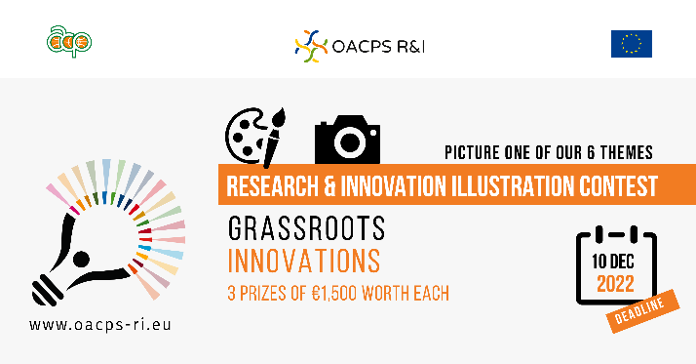
The illustration contest focuses on six thematic areas for their specific relevance to the OACPS R&I Programme.

One of them is about “Women and girls in STEM”.

In our changing technological world, Science, Technology, Engineering and Mathematics (STEM) are often seen as the jobs of the future, driving innovation, social welfare, inclusive growth and sustainable development. However, it is estimated that only 1 out of 5 jobs in STEM fields are filled by a woman, which contributes to great economic inequality in society.
The reasons for this inequity are multiple and complex, ranging from stereotypes about what kind of work women “can” or “should” do, male-dominated cultures, to a lack of support for women pursuing STEM careers. Despite efforts to balance the gender equation in STEM fields, there are still gaps at different levels of education and professional development in OACPS member countries.
The OACPS R&I Programme promotes women in STEM to demonstrate how the application of a “gender lens” leads to more effective, equitable and sustainable development.

