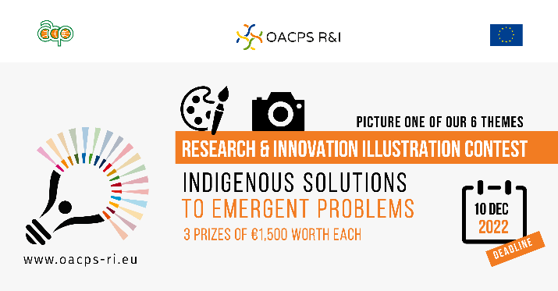
The illustration contest focuses on six thematic areas for their specific relevance to the OACPS R&I Programme.

One of them is about “Indigenous solutions to emergent problems”.

Drawing upon the distinct knowledge systems, practices and innovative technologies developed and maintained by indigenous people is crucial in tackling emerging challenges, such as climate change, biodiversity loss and pandemics.

Indigenous peoples have a special relationship with their lands (among the world’s most biodiverse and resource-rich), waters and oceans, upon which their lives and cultural identities strongly depend. They have been the guardians of biodiversity for thousands of years, accumulating and handing down knowledge about agriculture, environment, natural medicines, etc.
The OACPS R&I Programme promotes better synergy between research and innovation and indigenous knowledge for more resilient and sustainable resource management.

