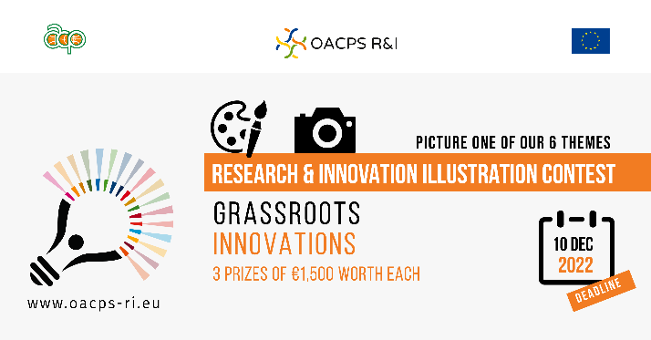
The illustration contest focuses on six thematic areas for their specific relevance to the OACPS R&I Programme.

One of them is about “Grassroots innovations”.

Grassroots innovation is often defined as innovative product or process created at the bottom of the pyramid, usually due to necessity, hardship and challenges.
Involving networks of neighbours, community groups, and civil society actors, it has the potential to generate novel, bottom-up, user-led and experience-based solutions that respond to local situations, interests and values, providing social, economic and environmental benefits to marginalised communities.
The OACPS R&I Programme gives added significance to grassroots innovation for more inclusive and efficient R&I ecosystems.

