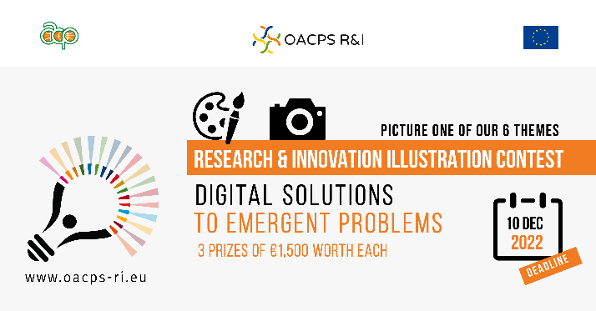
The illustration contest focuses on sixthematic areas for their specific relevance to the OACPS R&I Programme.

One of them is about “Digital solutions to emergent problems”.

At record speed, digital technologies are radically changing the world. Properly used, they can bring solutions to emergent problems. They can increase resource efficiency, help monitor and protect ecosystems, make essential services more accessible and affordable, reduce transaction costs and improve market access, help track and trace products to improve circularity and sustainability. They enable ideas, knowledge and data to flow more freely. Societies and productive sectors need to be prepared and equipped, and build the required skills and environment, to take advantage of digital technologies, notably frontier technologies (artificial intelligence – AI, the internet of things, big data, blockchain, 5G, 3D printing, robotics, drones, gene editing, nanotechnology, and solar photovoltaic).

The OACPS R&I Programme contributes to harnessing the power of digital technologies to accelerate and scale innovative solutions to emerging societal challenges with high potential for impact.

