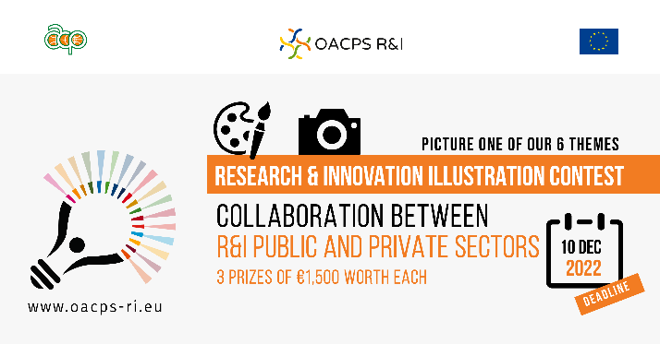
The illustration contest focuses on six thematic areas for their specific relevance to the OACPS R&I Programme.

One of them is about “Collaboration between R&I public and private sectors”.

A competitive, knowledge-based economy capable of sustainable growth requires integration of the four major actors in the innovation system: industry, government, academia and research institutes, and society (quadruple helix model of innovation). Researchers, academics, and private sector often work in silos, which limits their innovation potential.
Therefore, it is important to break down these silos and boost inclusive R&I collaboration, in order to access or develop critical talent, intensify knowledge exchange and technology transfer, get new innovations to market sooner, and achieve wide societal benefits.
The OACPS R&I Programme encourages more diverse and inclusive R&I ecosystems for maximising impacts.

